Package Production Workflow Functional Document

Application: | NGERP-CENTRA
WorkFlow: | Move To Stock
WorkFlow Item Name: | Package Production

Description:

This function is used to generate a bill of materials(BOM) products into the NGERP system.The finished product or goods may be the final product itself or a semi-finished product which is later consumed to produce a final or a larger product.

Work Flow Process:

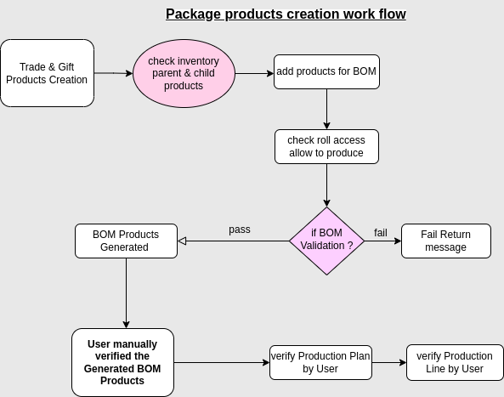

Business Rule:

- Before Create Package Production need to check the inventory of parent and child product’s inventory.
- Create Package Production with using BOM Product in ROW.
- Warehouse should be HCM HOLD,CDC HOLD,Hcm Gift Hold to add parent and child products
during production.
- Create the production plan using parent product.
- Create production line using “Create/Post production” button in Production header for the BOM product with two normal child products.
- Lot expiry Date automatically chooses by default system based on the parent lot no in FEFO(First Expire First Out) concept.
- System should allow the user to change Lot based on the BOM_product in production line tab.
- product qty added by user manually to generate the production.
- System allow to Create production line using “Create/Post production” button when Role access for Allow to produce is NO.
- System allow to Create production using “Create/Post production” button when Role access for Allow to produce is YES.
- Parent and child products lot and qty verified by user manually after done the production.

